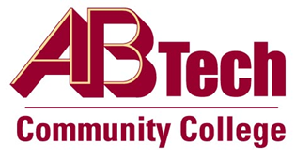

# Asheville-Buncombe Technical Community College (A-B Tech) Policy Manual

## Policy 1013: Disabling and Deleting User Accounts

It is the policy of the Board of Trustees that access to College resources shall be restricted to authorized users for only as long as that authorization exists. User accounts will be reviewed periodically and disabled when access is no longer required or permitted.

## Scope

This policy applies to all faculty, staff, students, and guests who have been issued a user account in order to access A-B Tech’s Information Technology resources and/or the College Network.

## Definitions:

User account: An identity created for a person for the purpose of accessing an information system.

## References

Access Control Policy SCIO-SEC-301 § AC-2, Account Management  
Approved by the Executive Leadership Team on September 6, 2023

## Policy Owner

Intermim Vice President, Information Technology, Ext. 7900

See Disabling and Deleting User Accounts Procedure

Approved by the Board of Trustees on September 11, 2023.